Earth and Space Science – Geology (M)

Student Name: ____Answers____

The following task consists of two parts. You will complete this task across two periods.

Section | Activity | Marks available
A | Looks at the theory behind the rock cycle. Answer the questions in the spaces provided. | /30
B | Is a practical assessment. Follow the instructions and write your answers in the space provided. | /24
 | TOTAL MARKS | /54

Section A: Rock Cycle Theory _________ /30 Marks

The Rock Cycle can be displayed as a diagram that shows the slow, continuous process of rocks changing from one type to another.
A trip through the rock cycle takes millions of years.

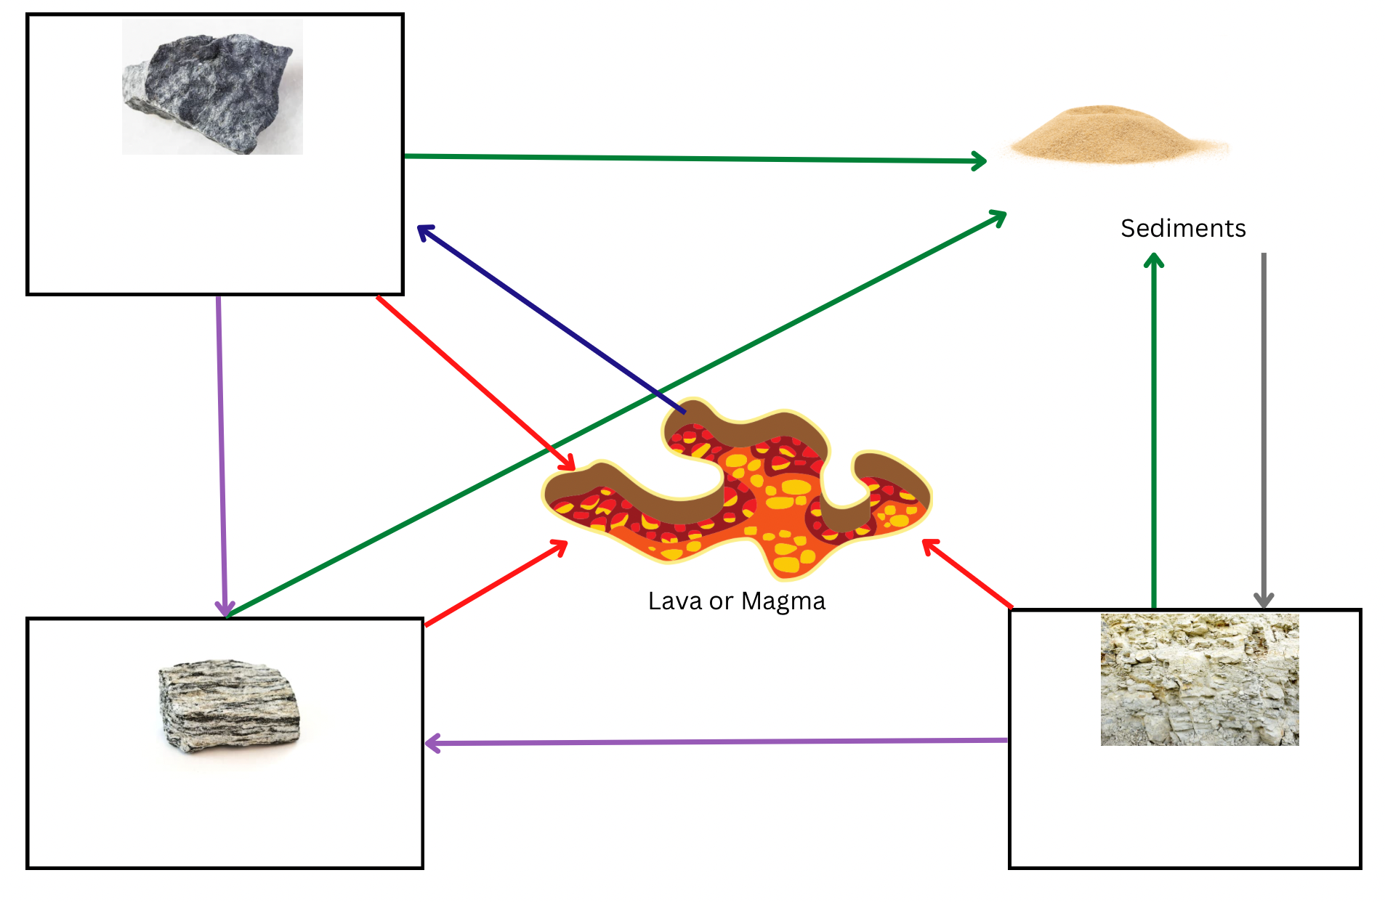
- Complete the rock cycle diagram below.
_________________________

IGNEOUS
_________________________

Sedimentary
Metamorphic
_________________________
______________________

- In each of the boxes, enter the type of rock. (3 marks)
Choose from the following words:
Igneous Sedimentary Metamorphic

- Complete the table by labelling each of the processes indicated by the arrow in the diagram above. Choose from the following words: (5 marks)
Weathering and erosion | Compaction | Cooling
Heating and Melting | Pressure

Coloured arrow | Name of process
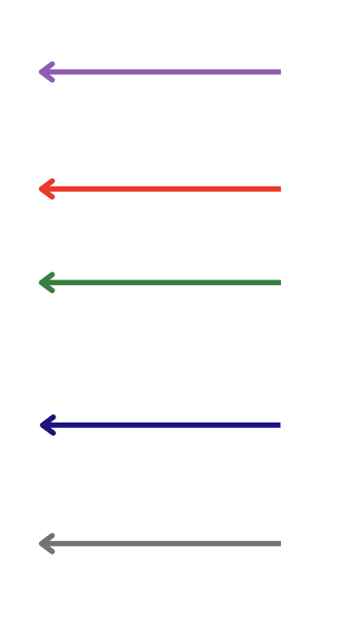 | Pressure
 | Heating or Melting
 | Weathering & Erosion
 | Cooling or Condensing
 | Compaction and Cementation

- Label the following rocks with either metamorphic, sedimentary or igneous.
(5 marks)
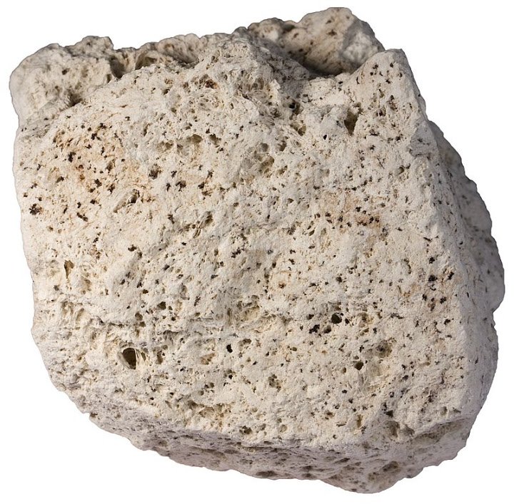
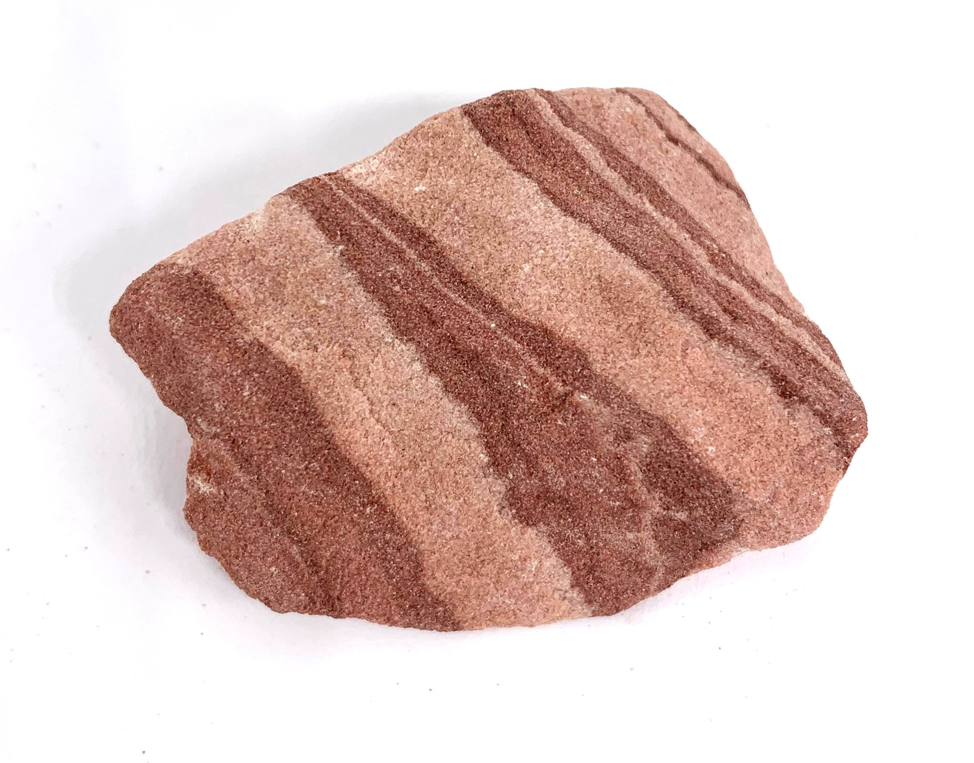
sedimentary
sedimentary
Igneous

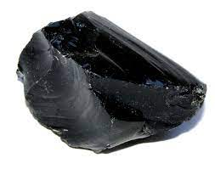
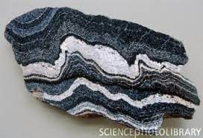

Igneous
metamorphic
____________________ _____________________

- Match the following words with their definition by drawing a line. (7 marks)

Word | Definition
Magma | Liquid rock that can be found on the surface of the Earth in areas like volcanoes
Intrusive crystals | Breaking down rock into smaller pieces
Extrusive crystals | Liquid rock that is beneath the surface of the Earth
Lava | Crystals that have cooled while inside the Earth
Weathering | Carrying sediments away to another place
Minerals | Crystals that have cooled while on the outside of the Earth
Erosion | Building blocks of rocks

- An archaeologist was on a dig in Australia. She came across a number of fossils as shown below.
Most recent layer created

- Which fossil is the oldest? (1 mark)
D

- Explain why you gave your answer in part a). (1 mark)

It is the bottom layer (first layer created)
- What rock type (metamorphic/sedimentary/or igneous) would she have been digging in? Why? (2 marks)
Sedimentary (1)
Because it has layers (1)

Use the following table to answer the following questions.

Mineral | Hardness | Common object
Talc | 1
Gypsum | 2 | Fingernail
Calcite | 3 | Piece of copper
Fluorite | 4 | Iron nail
Apatite | 5 | Glass
Feldspar | 6 | Steel file
Quartz | 7 | Streak plate
Topaz | 8 | Scratches quartz
Corundum | 9 | Scratches topaz
Diamond | 10 | Scratches all common materials

- What mineral is the hardest mineral? (1 mark)

Diamond
b) What mineral is the softest mineral? (1 mark)
Talc
c) Name two minerals that will scratch topaz. (2 marks)
corundum – 1 and diamond - 1
- Name two objects that will scratch fluorite. (2 marks)
Glass/steel file / streak plate / diamond

Section B: Rock Cycle Practical _________ / 26 Marks

Student Name: ____________________________

Materials:
- 1 Cube of sugar
- 10 cm² Foil
- 10 cm² White paper
- Candle
- Hand Lens
- Wooden test tube peg

Step 1: Examine the sugar cube with a hand lens

Observations - Describe what you see by completing the boxes below. |  | ___ / 3 Marks  ½ mark each
Grain size | approx. 1mm or less
Grain shape | Cubish
How close the grains are? | Very close together
Are the grains cemented together? | yes
Overall shape of the sample | Cube
State of Matter (Solid, liquid, gas) | solid

Conclusion - Relate your observations to the Rock Cycle | ___ / 3 Marks
What rock type does this represent?  Sedimentary  Explain why.  Individual grains (rocks) (1) cemented together (1) | ___ / 1 Mark  ___ / 2 Marks
Step 2: Place sugar cube on white paper square and use the back of the tongs to crush part of the cube into a powder.

Observations - Describe what you see by completing the boxes below. |  | ___ / 3 Marks  ½ mark each
Grain size | Less than 1mm
Grain shape | irregular
How close the grains are? | Far apart, spread out
Are the grains cemented together? | no
Overall shape of the sample | irregular
State of Matter (s,l,g) | S

Step 3: Fold the edges of the foil over to make a small bowl. Pour the crushed sugar into the foil bowl.

Conclusion - Relate your observations to the Rock Cycle | ___ / 2 Marks
What process in the Rock Cycle does the movement from place to place, of the crushed sugar represent?  Erosion  Explain why and how:  Moving the particles from one place to another | ___ / 1 Mark  ___ / 1 Mark

Step 4: Use the metal tongs to hold the bowl over the candle flame. Write down what your observations are as the sugar begins to melt.

Observation - Relate your observations to the Rock Cycle | ___ / 3 Marks
What process in the Rock Cycle does this replicate?  Melting  Explain how this comes about in the Rock Cycle:  Rock is forced beneath the crust into the mantle (1) where temperatures are high enough to melt rock (1) | ___ / 1 Mark  ___ / 2 Marks

Step 5: Set the foil bowl aside and let the sugar cool and harden. Write down what your observations are as the liquid begins to cool.

Observations - Describe what you see by completing the boxes below. |  | ___ / 1 Mark  ½ mark each
Grain present? | No
Overall shape of the sample | Irregular, shape of the container

Observation - Relate your observations to the Rock Cycle | ___ / 3 Marks
What process in the Rock Cycle does this replicate?  Cooling of magma  Explain how this comes about in the Rock Cycle:  When magma is forced to the surface of the Earth and becomes lava it cools, becoming hard  Igneous rock is formed | ___ / 1 Mark  ___ / 2 Marks

Step 6: Break the hardened sugar into pieces by crumpling the cooled foil a little. Write down what your observations are as the sugar begins to break up.

Observation - Relate your observations to the Rock Cycle | ___ / 6 Marks
What process in the Rock Cycle does this represent?  Weathering  What is produced from this process in the Rock Cycle?  Sediments  What do you notice about what you did in step 2, and what you did in step 6?  Same action, both produce sediments  What does this say about the rock cycle and the paths a rock can take?  The rock cycle is a continuous cycle  Rocks can move through different paths in the cycle | ___ / 1 Mark  ___ / 1 Mark  ___ / 2 Marks  ___ / 2 Marks

